October 2016
THE ACTONIANS next production is…….
HUMBLE BOY
By Charlotte Jones
24th – 26th November 2016
7.30 pm Iron Acton Parish Hall
Tickets £8; Children £5
Book at: www.actonians.co.uk or Call: 07807 547 238
Follow us on: https://www.facebook.com/Actonians or
email: actonians@outlook.com
This year’s autumn production is ‘Humble Boy’, an award winning comedy written by Charlotte Jones and first performed at the National Theatre in 2001. ‘Humble Boy’ is a comedy about broken vows, failed hopes and the joys of bee-keeping.
The action takes place in the garden of the Humble family home over a few weeks in the summer. Following the sudden death of his father, Felix Humble, a thirty-five year old astro-physicist returns to his Middle England home and his difficult and demanding mother. The play cleverly combines comedy with pathos as two families the Humbles and the Pyes come together.
Described by the Daily Telegraph’s Charles Spencer as ‘Rich, original, intelligent, funny and touching, bursting with ideas and characters you come to care about deeply.’
Tickets can be booked on our Website www.actonians.co.uk.
If there are any budding actors out there, you can contact us via our email address or come along to one of our regular Wednesday rehearsals in Iron Acton Parish Hall (from 7.30 pm). All comers are welcome to our very active and sociable group.
Junior Actonians is a thriving and growing group of young actors, aged between 11 and 17, who meet every Wednesday in term time in Iron Acton Parish Hall from 6:30 – 7:30pm. In February this year they were awarded the Denning Award for Youth Drama at the AAD One Act Festival. Any new members will be very welcome.
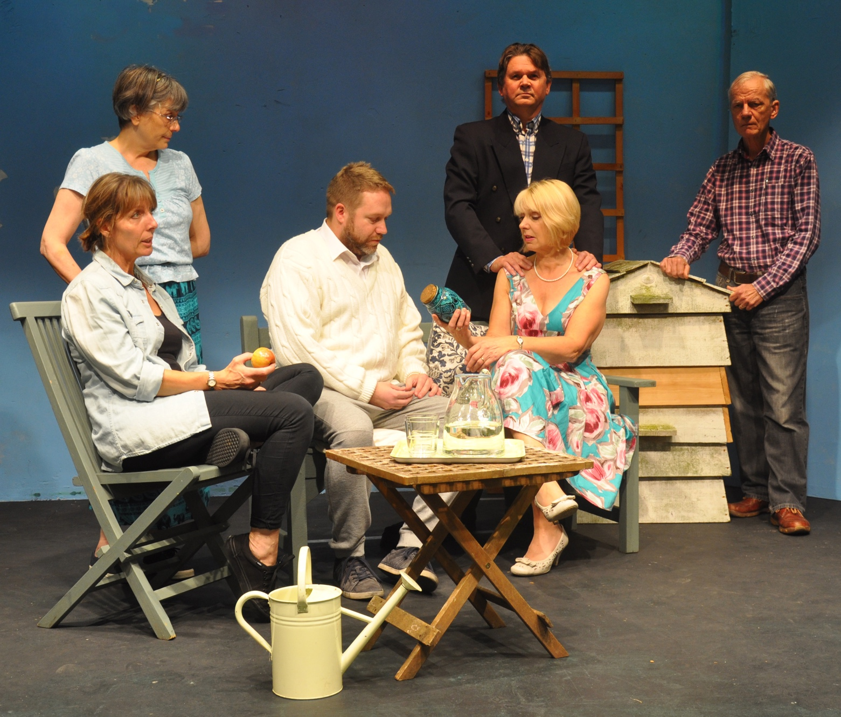
Photograph:
From left to right – Sarah Godsell, Sarah McMahon, Nick Pearce, Richard Stanway, Sue Anstey and Godfrey Laundy

